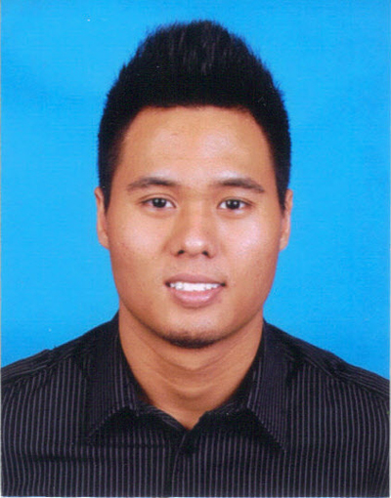

Residence : USJ 2/6, 47600 Subang Jaya, Selangor
Date of birth : 8th August 1990
Place of birth : Subang Jaya
NRIC : 900808-10-5301
Gender : Male
Height : 168cm
Weight : 70 Kg
Marital status : Single
Race : Malay
Religion : Muslim
Nationality : Malaysian
Tel No. : 03 – 80113292
H/P No. : 012- 3295 890
Email : fouler32@hotmail.com
Expected Salary : RM3000 and above

CAREER GOAL

- Seeking to obtain a rewarding career with a growth-oriented company that promotes a team environment and reaching the highest possible standards.

EDUCATIONAL QUALIFICATION

Lower Secondary School : Sekolah Menengah Seafield USJ Subang Jaya – 2003 -2005(PMR)

Higher Secondary School : Sekolah Menengah Seafield USJ Subang Jaya – 2003 -2005(SPM)
- SPM – 1A, 4B, 3C and 2D

BAHASA MELAYU | 4B
BAHASA INGGERIS | 3B
PENDIDIKAN ISLAM | 4B
SEJARAH | 6C
MATHEMATICS | 1A
ADDITIONAL MATHEMATICS | 6C
PHYSICS | 4B
CHEMISTRY | 7D
BIOLOGY | 7D
ENGLISH FOR SCIENCE AND TECHNOLOGY | 5C

ACHIEVEMENTS

- Certificate of Attendance - Outward Bound Malaysia – 13 Dec 2006 – 22 Dec 2006
- Certificate of Recognition - Intensive English - Taylors’s University College – July – Sept 2008
- Sijil Penyertaan - Kem Cabaran Kadet Bomba Tahap I & II – 2008
- Sijil Penyertaan - Pertandingan Tenpin Boling - 2007

ACTIVITIES

- Bowling - Ahli Biasa – 2005-2007
- Kadet Bomba - Ahli Biasa – 2007

WORKING EXPERIENCE

IP Strategic Xperts(ISX) Sdn Bhd (Outbound Microsoft Licensing Consultant) - January 2014 – Current

- Handling profiling database for Malaysia, Indonesia, Philippines and Australia for campaigners to perform outbound calls
- Calling potential customers from Malaysia and Australia to verify each and every company details provided as in the database
- Providing daily reports to the floor manager on the calls that has been made such as profiled or data pending
- Currently working close with Australian Companies to follow up regarding software updates and database

U Mobile Customer Service Executive – Nov 2011 – July 2013

- Handling inbound calls assisting customers related to modem/data troubleshooting, general enquiries for U Mobile prepaid/postpaid packages to ensure customer is satisfied with the service and understand the products/promotions held.
- Assisting Managers and Team Leaders To Handle New Coming Agents On The Floor, Doing Hourly Report For Postpaid, Prepaid and General Enquiries For Company’s Record.

Lenovo Promoter – April-June 2013 (2 Months)

- Part Timer Promoter – Assist potential customers by educating them about the new Colgate Plax product and giving out free samples.

COMPETENCIES

Computer Skills
- Possess a good grasp of knowledge and skills in using softwares such as Microsoft Office, PowerPoint, Microsoft Office Word, Microsoft Office Excel and Adobe Photoshop.

Communication Skills
- Fluent written and verbal communication in English and Malay Language

Interpersonal Skills
- Possess good analytical and problem-solving skills
- Cheerful, enthusiastic, fast-learner, self-motivated, resourceful and a team player
- Possess positive thinking and attitude towards any task given or situation

REFERENCES

Name : Mr Hairul Ahmad
Position : Manager
Contact No. : +0193957147

